HAZARD IDENTIFICATION TECHNIQUES

Introduction

In any work environment where man, machine and material are brought together to produce a product or perform a service, potential conditions may exist which may give rise to accidents. These potential conditions causing accidents at the workplace are called as hazards. In order to set realistic goals for accident prevention the organization must identify the hazards prevalent in the workplace and their location and assess the importance and potential effects. Control measures can then be instituted to help reduce risk and potential losses. Thus hazard identification is the first step in the hazard control program. Some general techniques for hazard identification are as follows:

    - Experience
    - Inspection
    - Safety Audit
    - Job Safety Analysis
    - What-If Analysis
    - Fault Tree Analysis
    - Event Tree Analysis
    - Hazard Operability Studies

EXPERIENCE

Experience is the most fundamental of all methods. Personal experience is important, but this particular section will concentrate on collective experience.

One method of building on experience is the “safety newsletter” approach. Some companies collect and describe accidents and abnormal incidents so that readers can check whether similar circumstances apply to their own units and take corrective action before an accident occurs.

Another method of building on experience, used by very large organizations with strong engineering functions, is to use standard designs and keep very careful records. Any defects which develop are analyzed and the standard designs modified to remove or control hazards.

A more general method of building on experience is to produce design codes which incorporate the collective experience concerning a particular class of equipment or equipment unique to a particular industry or both (pressure vessels, paper mills, etc.). These design codes are produced by codes writing or standards framing bodies as a collaborative effort by users, suppliers and regulatory bodies.

Every effort should be made to prevent the accident. However, if accident occurs it should be investigated to prevent its recurrence. As such accident prevention could be termed as a passive technique of hazard identification since it is conducted only in the aftermath of the accidents.

The failure of people, equipment, supplies, or surroundings to behave or react as expected causes most of the accidents. Accident investigations determine how and why these failures occur. By using the information gained through an investigation, a similar or perhaps more disastrous accident may be prevented. Accident investigation needs to be conducted with accident prevention in mind and not to place blame.

INSPECTION

Inspection is a monitoring function conducted in an organisation to locate and report existing and potential hazards having the capacity to cause accidents in the workplace. Inspection like investigation must be fact-finding and not fault-finding. Its primary purpose is to detect potential hazards so that they can be corrected before an accident occurs. Nearly all management levels and many workers are involved in conducting inspections.

Inspections must be carefully thought out and require sound knowledge of the organisation and its processes and equipment; knowledge of relevant standards, regulations and codes; systematic inspection steps; and methods of reporting, evaluating, and using the data.

Types of Inspection

Inspections can be classified as one of two types continuous and planned.

Continuous, ongoing inspections

Continuous, ongoing inspections are conducted by workers, supervisors and maintenance personnel as part of their job responsibilities. These do not conform to a set schedule, plan, or check-list and are erratic and superficial, that they do not get into out-of-the-way places, and miss too much. The truth is that both continuous and interval inspections are necessary and they complement one another.

As part of their job, supervisors make sure that tools, machines and equipment are properly maintained and safe to use and that safety precautions are being observed. Tool room workers regularly inspect all hand tools to be sure that they are in safe condition. Foremen, Supervisors are often responsible for continuously monitoring the workplace and seeing that equipment is safe and that workers are observing safe practices.

Planned Inspection

This process is what most people regard as "real" safety and health inspection. It is deliberate, thorough, and systematic. Planned inspections permit examination of specific items or conditions. They follow an established procedure and use checklists for routine items. These inspections can be any one of the three types; periodic, intermittent, and general.

Periodic Inspection includes those inspections scheduled at regular intervals. They can target the entire plant, a specific area, a specific operation, or a specific type of equipment. Management can plan these inspections weekly, monthly, semiannually, annually, or at other suitable intervals.

Intermittent inspections are those made at irregular intervals. If a particular department or location shows an unusual number of accidents or if certain types of injuries occur with greater frequency, the supervisor or manager should call for an inspection. When construction or remodeling is going on within or around a facility, an unscheduled inspection may be needed to find and correct unsafe conditions before an accident occurs. The same is true when a department installs new equipment, institutes new processes, or modifies old ones, or a new construction site is started.

A general inspection is planned and covers places not inspected periodically. This includes those areas no one ever visits and where people rarely get hurt, such as parking lots, sidewalks, fencing, and similar outlying regions.

Planning for Inspection

Before instituting an inspection program, these five questions should be answered:

- What items need to be inspected?

- What aspects of each item need to be examined?

- What conditions need to be inspected?

- How often must items be inspected?

- Who will conduct the inspection?

Checklists are effective tools for inspections and can help in follow-up to ensure all hazardous conditions have been corrected. Checklist is the foundation upon which a program of planned inspection is based. It resembles a planned preventive maintenance system and yields many of the same benefits.

Management should divide the entire facility - yards, buildings, equipment, machinery, vehicles-into areas of responsibility. These areas, once determined, should be listed in an orderly fashion. Large areas or departments can be divided into smaller areas and assigned to each first-line supervisor.

Once specific areas of responsibility have been determined, managers should develop an inventory of those items that may become unsafe or cause accidents.

Checklists are relatively easy to apply and probably will result in the identification of most of the “standard” hazards. Checklists usually must be long in order to be comprehensive – a disadvantage that can make the application tedious and mechanical.

Who Will Conduct the Inspection ?
Answering the four previous questions - the items to be inspected, the aspects of each item to be inspected, the conditions to be inspected and the frequency of inspections- will help to determine who is qualified to do the inspection. No individual or group should have exclusive responsibility for all inspections. Some items will need to be inspected by more than one person. For example, while an area supervisor may inspect an overhead crane weekly and maintenance personnel inspect it monthly, the operator of the crane will inspect it before each use. When grinding wheels are received, they are inspected by the store room attendant, but they must be inspected again by the operator before each use.

Five qualifications of a good inspector are:
- Knowledge of the organization’s accident experience.

- Familiarity with accident potentials and with the standards that apply to his or her area.

- Ability to make intelligent decisions for corrective action.

- Diplomacy in handling personnel and situations.

- Knowledge of the organisation's operations - its workflow, systems and products.

Practical Hints to make Safety Inspections useful.

A clip board with enough sheets used for noting, makes recording convenient.

The inspection should be slow and the inspector should give sufficient time to study each job situation thoroughly.

Anticipating the typical findings likely to come across, and having ready-made checklists prepared in advance and readily available for consultation, makes the job easier. The check list helps to ensure that no aspect is left out.

Co-operation of workers is important and consulting them is useful. The purpose of the inspections should on no account be treated as a secret or held back from the workmen.

Once the inspection is complete, it will be advisable for the inspector to go through the points and whenever in doubt, collect more information. If necessary, a second round can be made. Technical help may be sought from the manager concerned or other experts, whenever needed.

Efforts should be made to find out contributory or supplementary causes for unsafe acts/conditions.

Inspection reports should be presented in such a way that the reader gets the idea quickly. Vague and general statements are best avoided. So are words like "can be improved" and "proper arrangements".

The recommendations should be made known to the persons who are responsible for corrective action.

In the subsequent inspections, the previous recommendations should be looked into and the new position compared with the old. Whenever recommendations are not implemented, the reasons should be ascertained.

Needless to say that senior executive in the company should go through the inspection reports and follow up correction action.

Frequency of inspection is determined by five factors: (1) loss severity potential of the problem, (2) injury potential, (3) rate at which the item can become unsafe, (4) past history of failures, and (5) regulatory requirements.

SAFETY AUDIT

Safety Audit is a systematic, objective and critical appraisal of a company's occupational health systems and safety programmes. It verifies the safety system's ability to achieve defined safety objectives by reviewing the operating procedures, emergency plans, and adequacy of maintenance, safety inspection, process hazards, personal protection standards and accident records. It is basically a self-regulatory system adopted by the industry.

There are two types of audits, external and internal. External Audits are those carried out by agencies external to the audit organization. Internal Audits are those carried out by the employees designated by the management for this purpose. Such employees may be selected preferably from amongst not having direct responsibility in the areas being audited nor having responsibility for implementation of recommendations.

Objective of a Safety Audit

The objective of a safety audit is to critically evaluate the effectiveness of the safety programme being practiced in the organization. It aims at assessing whether the practices being followed comply with the statutory requirements or meet the standard codes of practice. It carries out a systematic and critical appraisal of all potential hazards involving personnel, plant, services and work methods and evaluates the effectiveness of the procedures for controlling them. Above all the audit recommends ways to improve the process and procedures to make the system safer through better management practices. However, safety audit is an effective tool only when its recommendations are accepted and implemented.

Elements of an Audit

Each safety audit should be conducted under the guidelines of a checklist prepared specifically for the purpose. Following are the broad areas of examination for the audit of any industry/construction establishment:

(i) Safety Management (ii) Industrial hazard control (iii) Industrial hygiene (iv) Training (v) Safety promotional activities (vi) Accident reporting, investigation and analysis of records. (vii) Statutory requirements (viii) Fire and explosion hazards (ix) Electrical hazards (x) Chemical hazards (xi) Safety in construction activities (xii) Personal protective equipment

Each of the above areas will comprise a number of elements. These elements should find a place in the checklist. An example of such elements in ‘Safety Management’ may comprise:

(i) Safety policy (ii) Safety department (iii) Safety Committees (iv) Standard/ Safe operating procedures (v) Safety manuals (vi) Training at various levels (vii) Plant safety inspections (viii) Accident reporting and investigations (ix) Involvement of top management in safety (x) Medical examination of employees (xi) Assignment of accountability and responsibility.

To get an effective feedback from various levels of the management and workers, the top management should instruct the line management to provide all co-operation to the audit team. The audit team should keep the top management informed of the procedure being followed and should involve them in the preparation of the action plan to implement the recommendations.

Steps in a Safety Audit

The following are the steps that are followed in conducting a safety audit:

- Collection of preliminary information on the process and the safety provisions that exist, through a pre-audit questionnaire.

- Preparation of an audit checklist to suit the requirement of the plant to be audited.

- Field visits - Inspection of various areas discussions with employees at various levels, and examination of documents, procedures and records.

- Completion of checklist and analysis of the data collected.

- Preparation of the audit report with recommendations

- Chalking out an action plan in consultation with the management to implement the recommendations.

Composition of a Safety Audit Team

The Safety Audit Team should be multi-disciplinary. It should consist of persons with wide experience in design, operation, maintenance and safety. For a conventional engineering industry, a team of three to five specialists may be considered adequate. The team should be assisted by a senior manager from the organization for the purpose of co-ordination.

Preparation of Audit Report and Recommendations

The audit report may begin with an executive summary of the findings of the audit. This will be followed by the detailed report which may be divided into the following parts:

- Introduction
- A brief description of the plant or site under audit
- Objectives of the audit
- Methodology
- Filling up of checklist
- Plant visit
- Perusal of records
- Discussion with management and workers
- Observations
- Recommendations

The recommendations made in a safety audit report should refer to statutory provisions such as various Acts and Rules, or non-statutory standards such as IS specifications, codes of practice from professional bodies or those based on sound management principles and indicate the person responsible for implementation of the recommendation and the target date of completion.

FAULT TREE ANALYSIS

The method essentially consists of defining an undesired event (called the “Top Event”) and then constructing the fault tree, using certain symbols, to know the basic causes. The fault tree is actually a logic diagram, which traces all the events that are likely to lead to the undesired event (top event) being studied. Each contributing factor or cause is then studied and analyzed to determine how it could occur. Such tracing of causes and factors can identify many different system failures, which might otherwise go unnoticed. The fault tree method is a systematic, descriptive form of analysis that can be applied to safety or reliability analysis. Fault tree analysis (FTA) is a logical, structured, graphical method that can help identify the potential caused of system failure and the undesired outcome before the failures actually occur. It uses a deductive technique using certain symbols and logic relationships for events within a system safety model. It focuses on a particular accident event (called the “Top Event”).

There are two logic gates, called the ‘AND’ gate and the ‘OR’ gate. These logic gates are similar to those used in the electronic circuit diagrams. The AND gate is the indication that all events immediately below it must occur to allow event immediately above it to occur. The OR gate indicates that occurrence of even any one of the events immediately below it will cause the event immediately above it to occur. This means that in a fault tree, an OR gate signifies a greater degree of risk than an AND gate in the event sequence. Also, the AND gate reduces the probability of an event, whereas an OR gate increases the probability.

The various symbols used to draw the fault tree are given below:

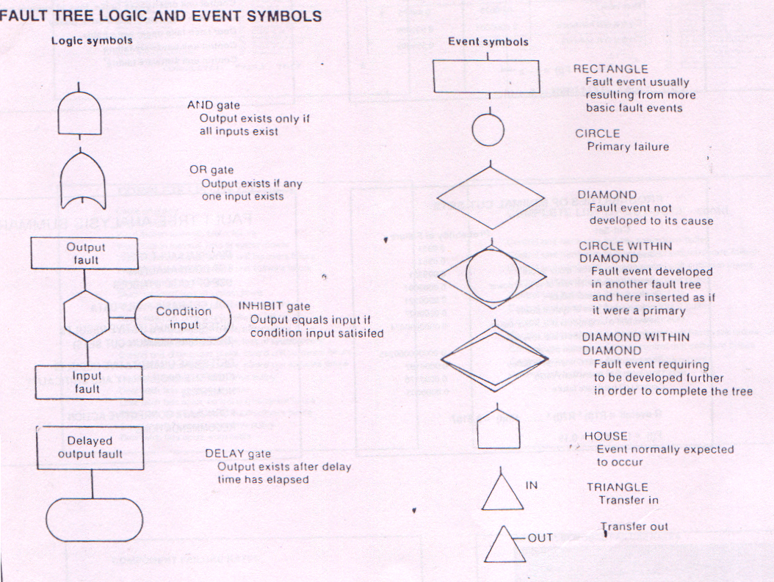

The fault tree determines the sets of events that cause the outcome (top event) in question. It can be used in the early design stages of new system and also in the case of an existing plant or system. Fault tree analysis can be carried out by a single person or a team. However, the person or team carrying out this analysis must be fully conversant with the process or operation and the associated hazards. The making of a fault tree diagram proceeds fundamentally by the analyst’s or team’s obtaining the answers to the questions as to what can cause an event to occur. The responses elicited are carefully and logically structured in the diagram, using only the prescribed symbols and logic gates. Making a fault tree is an elaborate and time-consuming process. The symbols and the logic gates used in the fault tree are described in Annexure. The fault tree focuses on a particular accident event (called the “Top Event”). It displays various combinations of fault events, which include equipment fault and failures as well as the human errors that can cause an accident. It breaks down an accident into the basic equipment failures and human errors and allows focus on the preventive measures on these basic causes. Usually it is a qualitative tool. However, if the probabilities of the basic fault events are known, the probability of the occurrence of top event can be determined. The fault trees are usually developed vertically downwards, but, alternatively, they can be developed horizontally (from left or right) also. There are certain ground rules, which must be followed while developing a fault tree. These are:

- A basic event (usually a malfunction) requiring further development must be described in functional terms in a ‘rectangle’.

- Events not requiring further development must be described either in a ‘circle’ (primary fault, usually expected to happen) or a ‘diamond’ (secondary fault, consequence insignificant or further information not available).

- Between two successive events there must be a logic gate (‘AND’ or ‘OR’ gate as appropriate) that is, two logic gates cannot be connected directly.

- The events rectangles, circles and/or diamonds) and the logic gates (‘AND’ gate or ‘OR’ gate) are appropriately joined by straight lines. These lines should be vertical and horizontal and should not cross each other.

- If one sheet of paper does not suffice to accommodate the fault tree, it should be continued on another sheet, using the appropriate triangular ‘OUT’ and ‘IN’ symbols with corresponding identifying serial numbers inscribed within to connect the diagrams on different sheets of paper.

- The fault events and the logic gates follow a “hierarchy system”. It means that, in a vertically developed fault tree diagram, the events at second level will be in the same horizontal level and, similarly, the logic gates and the events at the third level will be at the same horizontal level, but below the second level, and so on. Check this out in the example of fault tree given below.

Example Fault Tree Analysis -

Tank Overflow


And

Tank level increases
No corrective action taken

Or
Or

Inlet Flow too great
Outlet piping plugged
Control valve fails closed
Operator fails
And
High level alarm fails

Pump motor fails
Motor Alarm Fails
Operator Fails
No corrective action
Or

EVENT TREE ANALYSIS

This is another useful deductive method for hazard analysis. It evaluates the potential accident outcomes due to a specific event like equipment or system failure or due to human error. This event is called the “Initiating Event”. The initiating event is like a seed from which develops an event tree, which helps us to know the possible consequences. Event tree analysis helps in finding out the possible consequences, depending upon how the operating personnel react and how the control system responds. An event tree can be developed by an individual person or by a team, but the person or the team should be fully conversant with the plant and process. Event tree is analogous to the “decision tree” often used as a management tool. It uses only horizontal and vertical lines (‘branches’) and no symbols. The event tree can be developed either horizontally or vertically. In a horizontally developed event tree, the vertical branch moving upward indicates a ‘SUCCESS’ (or ‘YES’) and the vertical downward branch, a ‘FAILURE (or ‘NO’). Event tree analysis is useful for systems having safety systems or emergency procedures to respond to the initiating. Factors such as the operator intervention, response of control systems and instruments are expressed more readily in the event tree analysis. This analysis can be useful in emergency management planning. The basic difference of the outcomes of a fault tree and an event tree is that the former goes to the ‘roots’ (the basic causes) and the latter to the ‘fruits’ (the consequences). To know the basic causes of an event as well as the possible consequences, a Cause-Consequences Analysis can be used. A cause-consequence analysis is a blend of fault tree and an event tree for the same event called the ‘Critical Event’.

Example – Safety Review for Silane Storage and Delivery Room.

System Description

In a typical hazardous materials storage and delivery room, protection systems are engineered and installed to prevent and mitigate hazardous situations such as leaks, fires and toxic exposures. For silane rooms, multiple protective systems are used due to the unpredictable nature of the gas and the potential for delayed or immediate explosions of this pyrophoric gas.

Safeguard systems:
- 1. TGM detects leak at below LEL and activates cylinder-closing device.

- 2. TGM detects leak above LEL and activates cylinder-closing device.

- 3. Decision point – flame or no flame from leak. No flame assumes toxic gas monitoring systems (TGM) fails to detect, therefore a possibility of explosive cloud formation exists.

- 4. Flame detector senses flame and activates cylinder-closing device.

- 5. Explosion is contained in gas cabinet.

- 6. Explosion contained in room, area flame detection / fire suppression activates.

- 7. Local response team or fire dept. contains external fire before factory is affected.

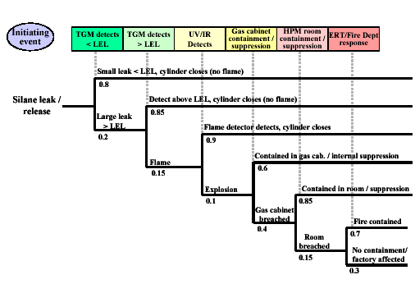
Event Tree

